**Classic Hall Effect Primer for the Quantum Hall Effect Experiment**

**The effect:**

**2.)**

**1.)**

**I+**

**I-**

**I+**

**Current**

**charge carriers**

**B-Field**

**to sample**

**B-Field**

**to sample**

**I-**

**4.)**

**I+**

**I-**

**I+**

**I-**

**3.)**

**Charge carriers build up on one side, creating a field countering the magnetic force on the flowing charges**

**charge carriers**

**charge carriers**

**B-Field**

**to sample**

**charge carriers**

**I+**

**I-**

**5.)**

**NOTE: In (3) the direction of applied magnetic field (in or out of the page, in this example) in addition to the sign of the charge carriers will determine the direction of rotation of the charges. Be careful to apply the magnetic field in a consistent orientation! If the B-field is applied consistently, changing the sign of the charge carriers from electrons (-) to holes (+) will reverse the sign of the hall voltage- meaning you can determine the sign of the charge carriers.**

**V+**

**V-**

**VHall**

**The Experiment:**

**The purpose of this part of the lab is to develop a better understanding of the Hall Effect and prepare for the Quantum Hall experiment later on. The samples and equipment are analogous to what you'll be using with the cryostat, but you'll be interacting with things directly instead of a more automated process.**

**Your task is to:**

**1.) Determine the type of charge carrier in each sample (holes or electrons for samples "A" and "B")**

**2.) Calculate the carrier density of each sample**

**The relevant Hall Effect equation is:**

**(1) $V_{Hall}=-\frac{IB}{net}$**

**Where "I" is current, "B" is magnetic field, "n" is the current density of the charges, "e" is the charge of the carriers (will be +/- the charge of the electron), and "t" is the sample thickness.**

**Equation (1) is valid for simple metals, but the samples are doped Germanium- it is a semiconductor containing both carrier types, but for the purpose of the experiment you can assume one type dominates (further exercise: look into how this changes when it's a semiconductor with both charges- and you can look at measuring mobility/effective mass). Additionally, you cannot directly measure VHall, as there is a current-dependent offset:**

**(2) $V_{⊥}=V_{Hall}(B)+V_{offset}(I)$**

**Therefore, measuring the current density "n" will require that you measure the hall voltage for a fixed current. Also note that this offset is geometry-dependent, so swapping your current supply and voltage measurement leads will change the offset.**

**Questions you should answer:**

**1.) What do you think the source of Voffset(I) is?**

**2.) How does Voffset(I) depend on I?**

**The Equipment:**

**1.) The magnet**



**The direction of the field is labeled for current traveling in the direction of RED to BLACK. This direction is important for finding the sign of the charge carriers. This magnet is composed of two solenoids with iron cores to boost the field. Connect the current to the magnet so that it travels in one side and then the other in series.**

**2.) The hall probe**

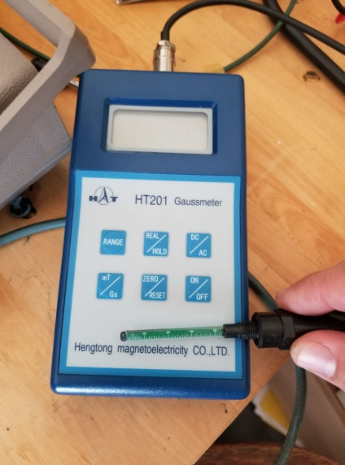

**\*\*IMPORTANT**: The probe is basically glass (it's another semiconductor), so banging it into anything has a good chance of breaking it. Verify what units you're looking at, as it can switch between some variation of Teslas and Gauss. The hall probe will display a value for the magnetic field that is entering perpendicular to the long rectangular probe. Try and have the probe in roughly the same spot as the sample. Your goal is to keep the field relatively constant, or at least avoid it drifting so far that it encroaches on another set of readings.**

**3.) The magnet current supply**

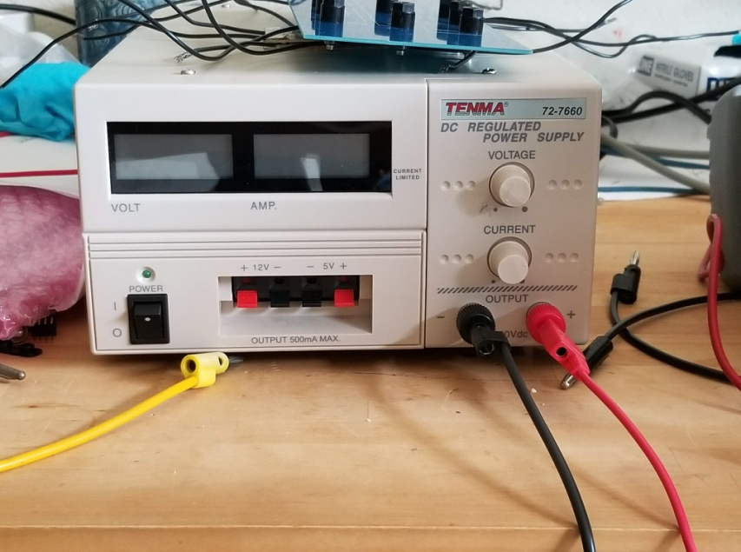

**Connect the Red (+) to the Red lead of the magnet and Black (-) to Black. Use this to read the current through magnet. You can measure the magnetic field using the hall probe (2). Is the field linearly dependent on current? Short answer: no. Is the field constant with time? Short answer: again, no- especially at higher current. There's a lot working against you, so you'll want to occasionally verify that your field isn't drifting too much. Historically, using a 0V measurement and 5V steps up (to ∼30V) has worked well for a range of magnetic fields.**

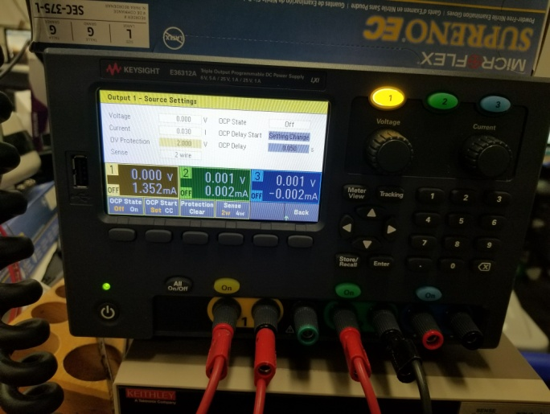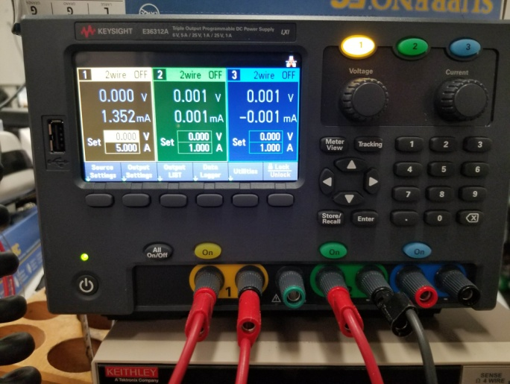 **4.) The sample current supply**

**This will be connected to the current inputs on the sample through the current meter (5)- please confirm that you know how to wire up a current meter in a circuit. You will use this to send current through the sample. **IMPORTANT**: you can break the sample by driving too much current through it- it's a crystal under a good amount of mechanical stress, so heating it isn't ideal. USE OUTPUT 1 and keep the current below 30mA, which is achievable with < 2V. You will be using small voltage steps (you have 1mV resolution) and plotting the resulting current through the sample vs the measured hall voltage.**

**5.) Sample current meter**

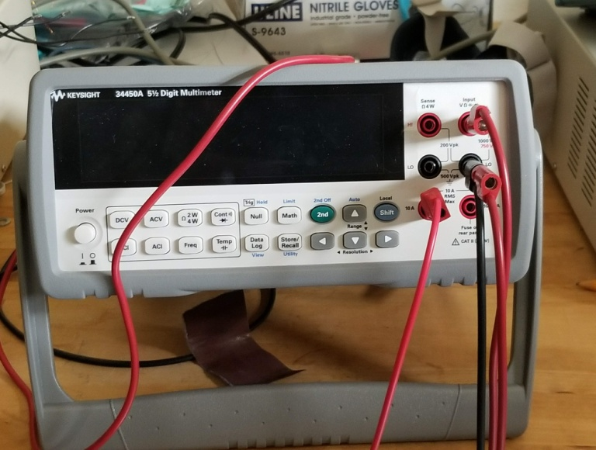

**Please confirm that you know how to wire up a current meter in a circuit. Additionally, confirm that you are using the correct input and output ports. This should be wired up in series with the sample current supply before going into the current inputs on the sample.**

**6.) The samples**

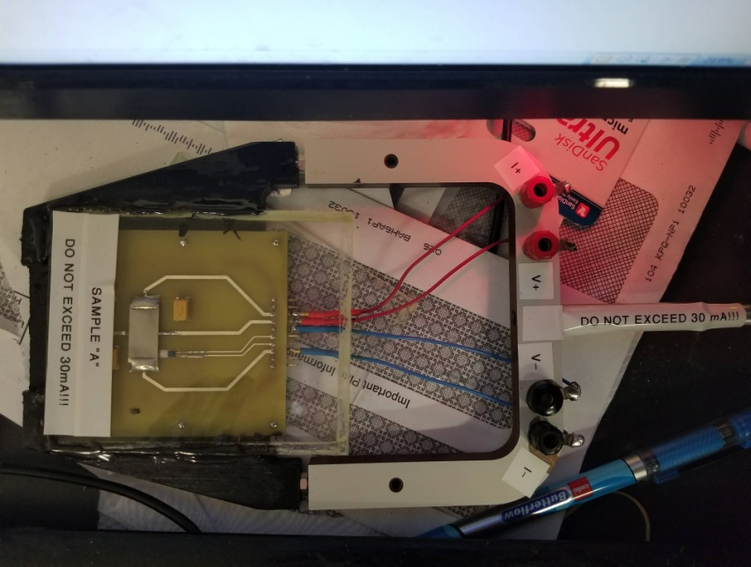

**This houses your doped germanium samples, which are very delicate (mechanical stress, heat, etc will all potentially break the sample or the connections). Keep the current under 30mA (this is achievable at < 2V out of the sample current supply), and know that leaving it at a higher current will heat the sample, changing the resistivity- a semiconductor behaves the exact opposite of a regular conductor, so heating the sample will LOWER the resistivity. If your power supply is sitting at constant voltage, this will cause current to go up (BAD!) over time. The sample current supply, after being connected through the sample current meter, is connected to the I +/- ports. The voltage meter is connected to the V+/- ports.**

**7.) The voltage meter**

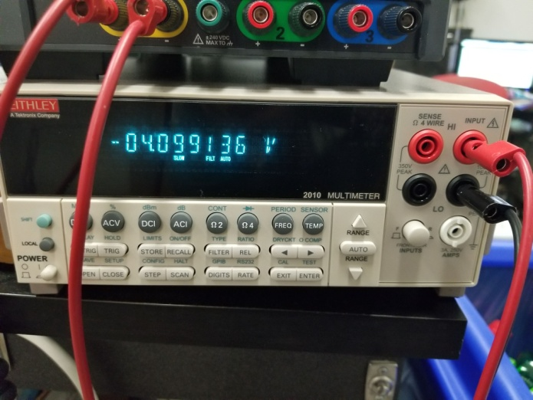

**Connect to the V+/- ports on the sample. You may find it useful to press the "rate" button on the front panel to slow the rate the digits are changing- expect a good amount of electrical noise in the room, which will affect the last few digits.**

**Final circuit will resemble the following (but check your leads!):**

**Sample current supply**

**Sample voltage meter**

**Sample current meter**

**Magnet current supply**

**Magnet  
pole**

**Magnet  
pole**

**SAMPLE**

**What should you expect to see?**

**V**

**T**

**I ↑**

**I**

**V**

Note: You're not going to intercept the origin. See the reading about voltage offset on the tesla.phys page

**B↑: P type  
B↓: N type**

**B↑: N type  
B↓: P type**

**I**

**V**

**B = 0**

**V**

**B**

**I ↑**

**THEORY: EXPERIMENT:**

**Last updated: 2019-06-26 by Ken Sikes**